LAB NO.03

**2.1 Working on Star Topology by using Packet Tracer and Network Switch**

**PREREQUISITES:** Laptop / PC, Packet Tracer Simulation Software, UTP Cable (Cat 5,6), Network Switch / Hub

**Theoretical Knowledge:**

**Star Topology:**

* In local area networks with a star topology, each network host (for example a PC) is connected to a central hub with a point-to-point connection. All traffic on the network passes through the central hub.
* The star topology is considered the easiest topology to design and implement.
* An advantage of the star topology is the simplicity of adding additional nodes.
* The primary disadvantage of the star topology is that it may need a lot more cables, and if the hub breaks everything will stop working.
* All the computers interact with each other, and the information will be shared to all the computers.

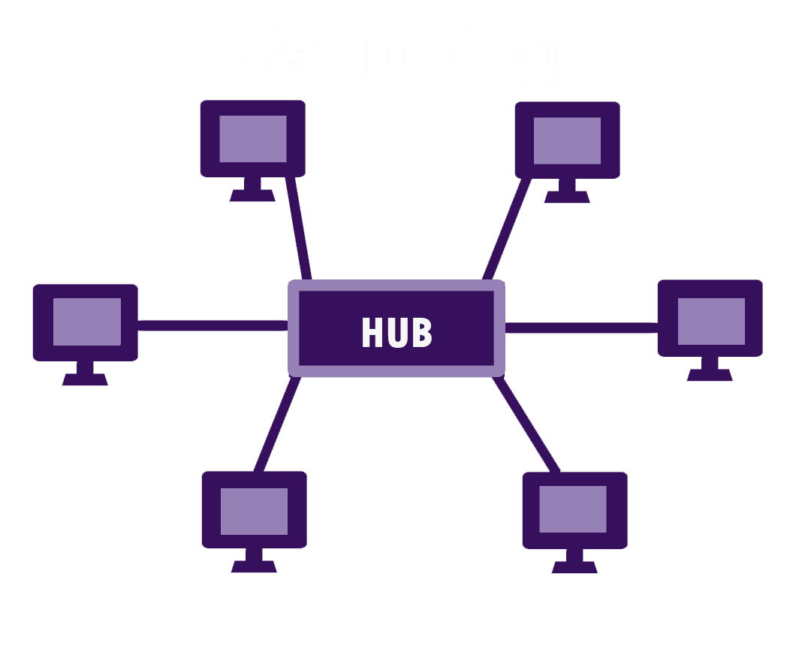

**Hub / Network Hub**

* Hubs connect multiple computer networking devices together.
* A hub is the simplest in the family of network connecting devices.
* Hubs do not perform packet filtering or addressing functions; they just send data packets to all connected devices.
* Hubs operate at the Physical layer of the Open Systems Interconnection (OSI) model. There are two types of hubs: simple and multiple port.

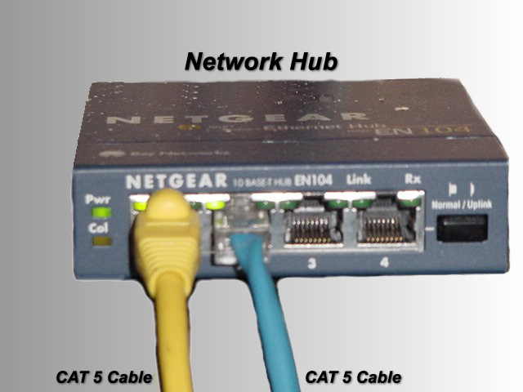

**SWITCH / Network SWITCH**

* Switches generally have a more intelligent role than hubs. A switch is a multiport device that improves network efficiency. The switch maintains limited routing information about nodes in the internal network, and it allows connections to systems like hubs or routers. Generally, switches can read the hardware addresses of incoming packets to transmit them to the appropriate destination.
* A switch can work at either the Data Link layer or the Network layer of the OSI model. A multilayer switch is one that can operate at both layers, which means that it can operate as both a switch and a router. A multilayer switch is a high-performance device that supports the same routing protocols as routers.

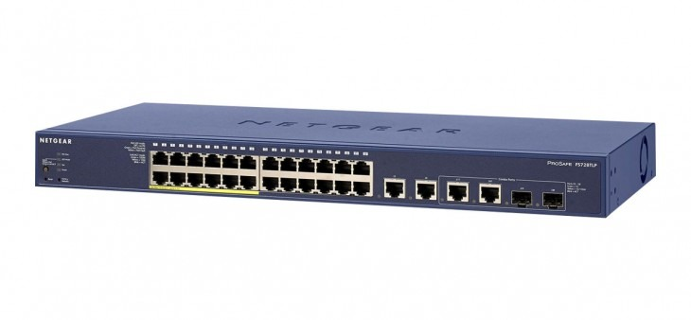

**Procedure / Steps**

**Through Cisco Packet Tracer:**

**Step 1:** Open Cisco Packet Tracer Application and login with your netacad credentials. If you don’t have netacad account, then you must create it first.

**Step 2:**  Go to network devices option at the left bottom of packet tracer screen and choose Hub as a network device.

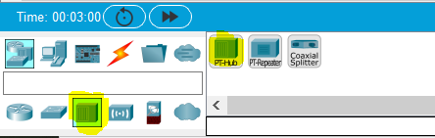

**Step 3:**  Go to end devices option at the left bottom of packet tracer screen and choose Five Devices (PCs) from there.

**Step 4:**  Choose the right cable connection (Straight Through) as you are connecting two different devices this time and appropriate port in PC and network hub as well.

**Step 5:**  Assign the following Ips Configuration to the PCS.

**PC1:** IP Address: 192.168.1.10

Subnet Mask: 255.255.255.0

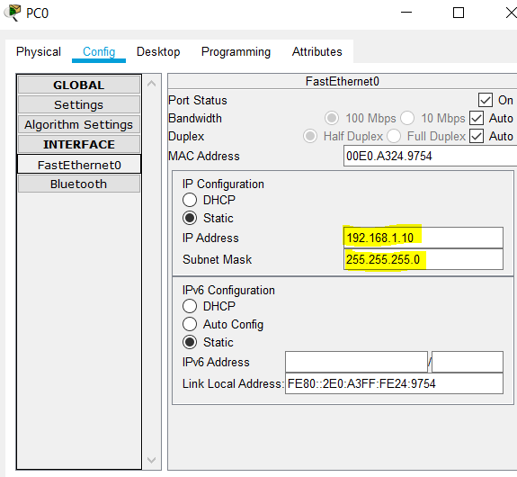

**Complete the Ips Configuration for Other PCs:**

**PC2:** IP Address: 192.168.1.20

Subnet Mask: 255.255.255.0

**PC3:** IP Address: 192.168.1.30

Subnet Mask: 255.255.255.0

**PC4:** IP Address: 192.168.1.40

Subnet Mask: 255.255.255.0

**PC5:** IP Address: 192.168.1.50

Subnet Mask: 255.255.255.0

**Step 6:**  Double click on PC1 then go to desktop and then the command prompt and check the connectivity with other PCs by using the following commands:

Ping 192.168.1.20 and press enter

Ping 192.168.1.30 and press enter

Ping 192.168.1.40 and press enter

Ping 192.168.1.50 and press enter

**Note: Repeat step 6 for other PCs as well.**

**By Using Network Switch / Hub**

**Step 1:** Power on the Network Switch and wait to turn it on and boot properly (Mostly it takes up to 5 minutes to complete it POST (Power on Self-test).

**Step 2:** Use Straight through cable and connect your PC/Laptop to network switch on available port.

**Step 3:** Use Straight through cable and connect your PC/Laptop to network switch on available port.

**Step 4:** Go to the search bar of Windows 10 PC at the left bottom and write “setting” and then select the setting option popped up.

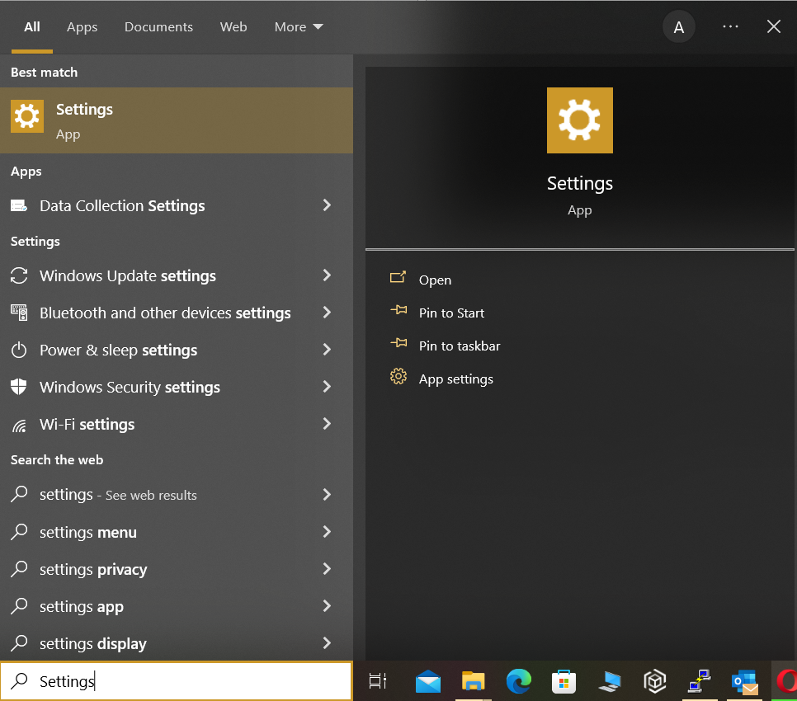

**Step 5:** On Settings page double click on **Network & Internet** option.

**Step 6:** Double click on“Change Adapter Option”

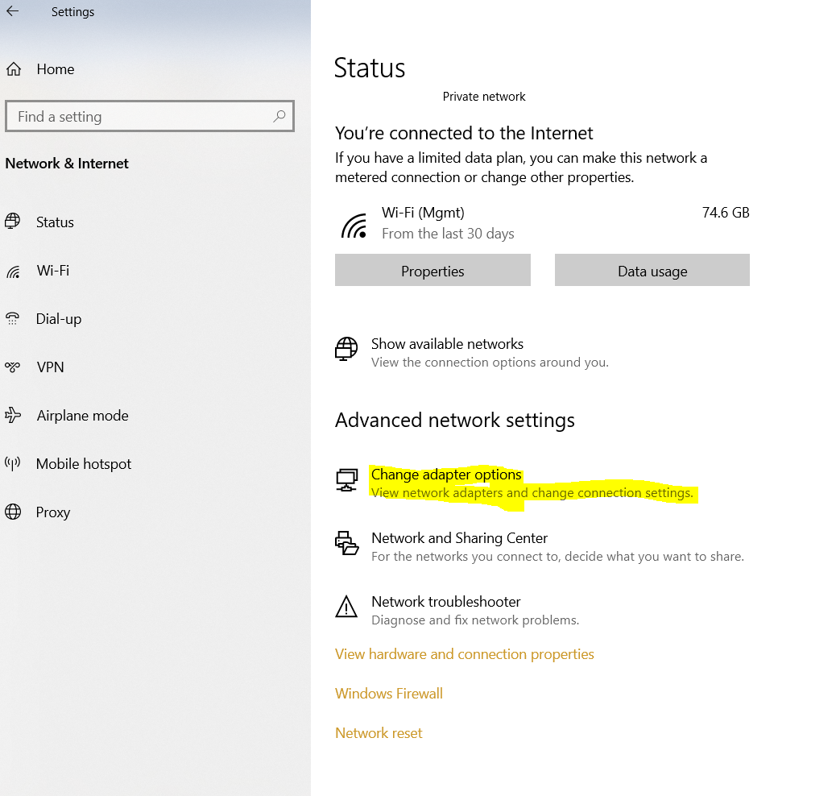

**Step 7:** Right click on **Local Area Network / Ethernet Adapter** and go to the properties.

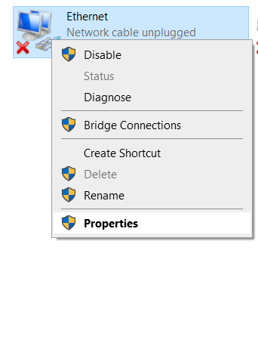

**Step 8:** Double click on **Internet Protocol Version 4 (TCP/IPV4)**

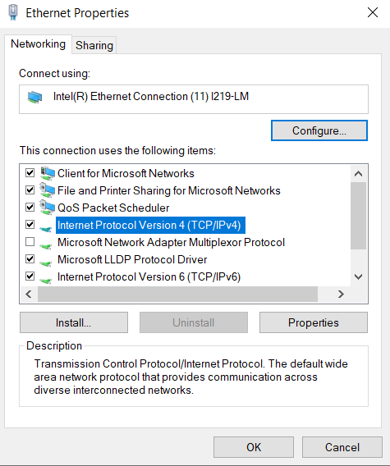

**Step 9:** Configure the PC-1 IP address as follows

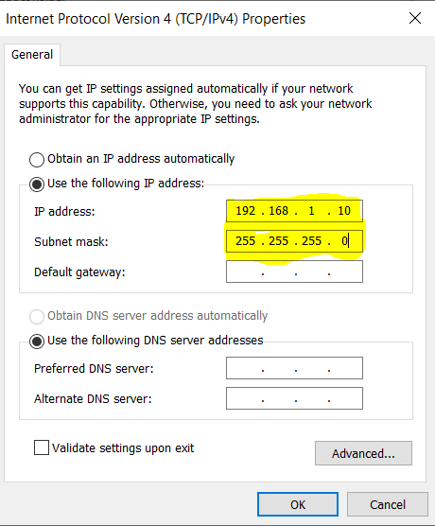

**Step 10:** Complete the IP Configuration of each PC.

**Step 11:** Turn off the Firewall of Windows 10 machine.

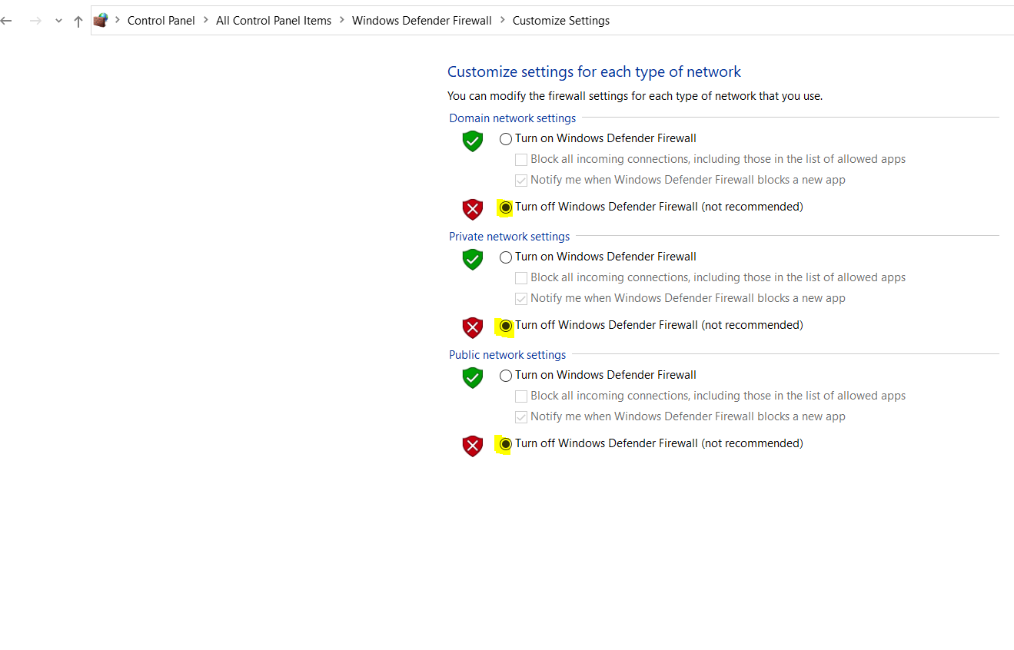

**Step 11:** Check and test the connectivity by using **ping** command.